**MOT2312 2022/2023**

**Research Methods (Exam; part Laurens Rook)**

Date: --

Time: --

Place: --

**Instruction**

--

**Question 1 (total score 8 points)**

Researchers investigated the impact of Stress Mindset (Stress is Enhancing, Stress is Debilitating) on the self-reported Satisfaction with Life. The (null and alternative) hypothesis tested was:

*Null Hypothesis*: Stress Mindset does not influence Satisfaction with Life.

*Alternative Hypothesis*: Stress Mindset influences Satisfaction with Life.

1. On the next page, you find the JASP output of an independent samples t-test for this study. Do we accept or reject the Null / Alternative Hypothesis? [open question; **1 point**]. Use the JASP output to motivate your answer [open question; **2 points**].

* We accept the null hypothesis --> **1 point**
* *t(*455) = -.224, p = .823 --> this test result is ns. (**1 point**), meaning that Stress Mindset does NOT influence Satisfaction with Life (**1 point**)

The researchers also posited that the participant’s Mood at test would not be influenced by their Stress Mindset (Stress is Enhancing, Stress is Debilitating) intervention (treatment). Specifically:

*Null Hypothesis*: Stress Mindset does not influence a person’s Mood at test.

*Alternative Hypothesis*: Stress Mindset influences a person’s Mood at test.

1. On the next page, you find the JASP output of a paired samples t-test for this study. Do we accept or reject the Null / Alternative Hypothesis? [open question; **1 point**]. Use the JASP output to motivate your answer [open question; **2 points**].

* We reject the null hypothesis --> **1 point**
* *t(*456) = 5.487, p < .001 --> this test result is sign. (**1 point**), meaning that Mood before and after the Stress Mindset intervention were different (**1 point**)

1. What is a Type I error? How is the Type I error related to hypothesis testing research, in general? [open question; **2 points**].

* Type I error = When you reject the null hypothesis H0 when it is actually true (so you say the H0 is false, while you shouldn’t have) --> [**1.0 point** for correct answer].
* The Type I error is one well-known decision error a researcher can make in the testing of hypotheses (the other one being the Type II error). It is caused by the confidence intervals (set at 95% or 99%) that always leave a margin of error (5%, 1%) --> [**1.0 point** for correct answer around these lines].

**JASP Outputs for Question 1**

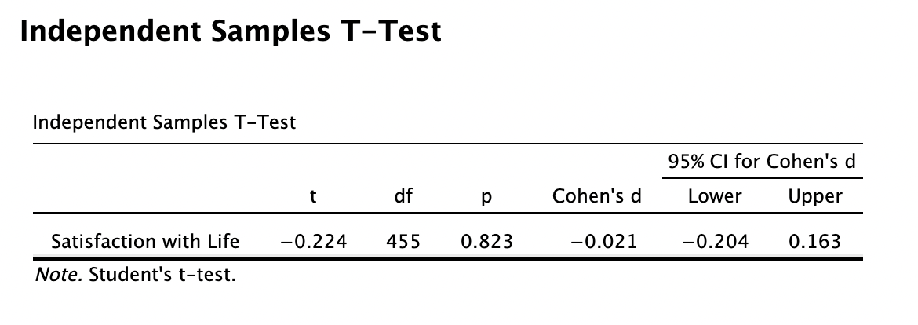

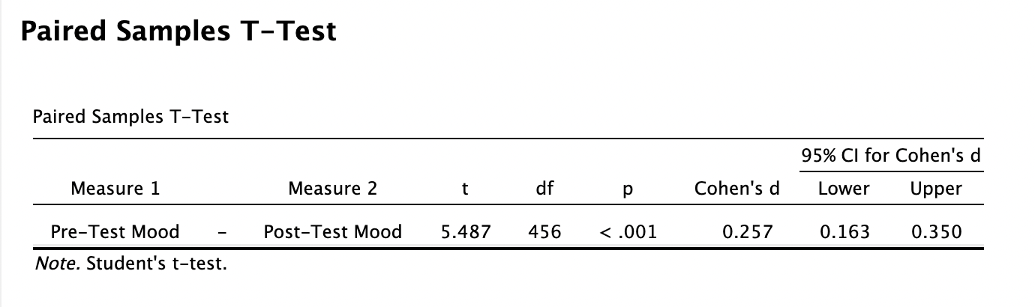

**Question 2 (total of 6 points)**

1. What are the main assumptions of the chi-square test of independence? Please describe them [open question; **2.0 points**].

* Nonparametric distribution (instead of the standard normal curve)
* Used for two nominal / categorical variables
* Based on a random sample with independent observations

1. On the next page, you find a JASP contingency table. It shows a chi-square test of independence for the variables Gender (Male, Female) and GAD (0 = no, 1 = yes). According to the test result, do men differ significantly from women on GAD? Use the JASP output to motivate your answer [open question; **2.0 points**].

* Chi-sqr test has p < .007 (which is significant): We reject H0 (no diff) and accept Ha (there is diff) --> **1 point** for this.
* Thus: men and women differ significantly on GAD--> **1 point** for this.

Based on a random sample with independent observations

1. What is your assessment of the valence and magnitude of the phi-coefficient in the JASP output? Motivate your answer [open question; **2.0 point**].

* Phi-coefficient = -0.227, which has a negative valence --> **1 point** for this.
* Phi = .10 is very small, Phi = .30 is medium. This value = .23, which is then probably small in terms of magnitude --> **1 point** for this.

**JASP Contingency Tables for Question 2**

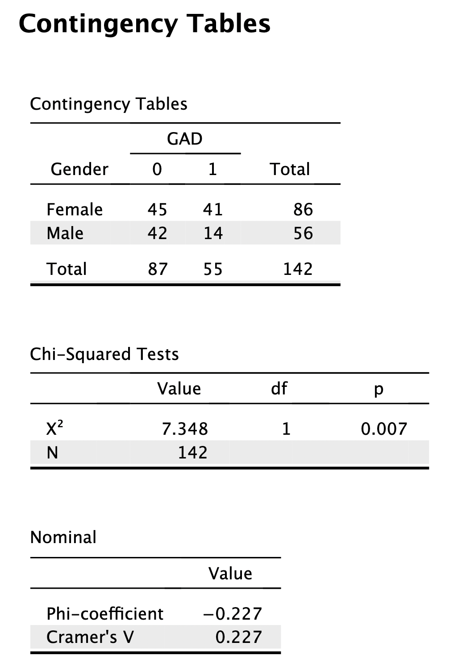

**Question 3 (total of 8 points)**

1. Which three (3) measures of variation are discussed in the Jackson book? Please mention and provide a brief description [open question; **3.0 points**].

*Range* = difference between lowest – highest score (1 point); *Average Deviation =* average diff between scores and mean of the distribution (1 point); *Standard Deviation* = the square root of the average squared deviation from the mean (**1 point** for each correct mention + description --> **0.5** (for mention) + **0.5** (for description))

1. Find the mean, median, and mode for the following sample of scores [open question; **3.0 points**]:

1 1 2 2 4 5 8 9 10 11 11 11

*M* = 6.25 (**1 point**); *Md* = 6.5 (**1 point**); *Mo* = 11 (**1 point**)

1. Suppose that Student A has a score of *X* = 75 on a research methods exam with $μ=60.$ Student B has a score of *X* = 58 on the same exam $.$ The standard deviation for the student population is $σ=9$. Calculate the *z*-scores that correspond with the respective exam scores of Student A and Student B. [open question; **2.0 points**].

Student A: *z* = 1.67 (**1 point**) Student B: *z* = -0.22 (**1 point**)

**Question 4 (total of 8 points)**

1. From a methodological point of view, how would you assess the validity of field experiments compared to the laboratory experiment? Motivate your answer [open question; **2.0 points**]?

* Internal validity = usually lower than the lab experiment (**1 point**)
* External validity = usually higher than the lab experiment (**1 point**)

A group of researchers conducted two field experiments on Facebook to investigate the effectiveness of psychologically targeted messages (tailored to the customer’s psychological profile) on actual online purchase (Study 1) and app install (Study 2). Eckles and colleagues (*PNAS, 115*(3), E5254-E5255, 2018) responded to this study. They identified several problems in the original field experiments as follows:

*“The authors used Facebook’s standard ad platform to compare how different versions of ads perform. However, users are not necessarily exposed to different ads. In Facebook’s standard ad platform, individuals may even have received multiple ad types (i.e., psychologically matching but also psychologically mismatching messages). Ad platforms like Facebook optimize campaign performance by showing ads to users whom the platform expects are more likely to fulfill the campaign’s objective. This optimization generates differences in responses across ads that do not by themselves indicate a causal effect.”*

1. We usually judge an experiment by three (3) building blocks that may (not) be present. Briefly mention and describe these building blocks [open question; **3.0 points**]?

* Randomization + description (**1 point**)
* Manipulation / treatment + description (**1 point**)
* Control + description (**1 point**)

1. Use the critique by Eckles et al. to argue which building blocks of the experiment probably were missing in the field experiments, and why? Motivate your answer [open question; **3.0 points**]?

* Randomization impossible due to FB optimization model (**1 point**)
* Manipulation / treatment poorly designed (conflicting treatments) (**1 point**)
* Control poor due to the above two aspects (**1 point**)